**Nizar Qabbani (1923 – 1998) - نزار قباني**

Mark D. Luce (

**Summary**

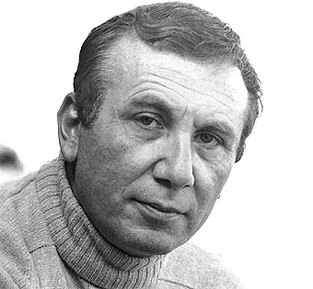

Nizar Qabbani (1923–1998) was born in Damascus, Syria into a merchant family. He studied law at Damascus University and then entered the Syrian diplomatic service, where he served in embassies in Cairo, Ankara, Beirut, London, Beijing, and Madrid.

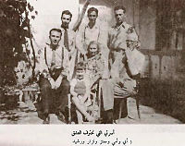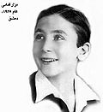

A family picture

<https://en.wikipedia.org/wiki/Nizar_Qabbani>

He retired in 1966, moved to Beirut and opened a publishing company. Qabbani was one of the most famous and influential poets of his time. He is known for his sensual and romantic poetry. He used poetry as a form of resistance to advocate for social freedoms for women and fused romantic themes with themes of political despair. Not only were his poems published, but they were popularized by Lebanese and Syrian singers who set his lyrics to music.

After the defeat of the Arabs in the 1967 Arab-Israeli War, Qabbani founded the Nizar Qabbani publishing house in London. He became a powerful and eloquent voice for Arab causes. As a strong Arab nationalist his works became increasingly more political. In his later years, his poems are very anti-authoritarian. Nizar Qabbani died in London of a heart attack at the age of 75.

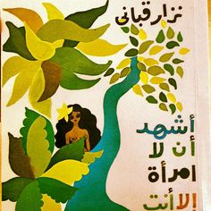. 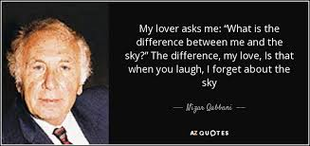

**Nizar Qabbani نزار قباني**

Nizar Qabbani as one of the greatest and most influential poets of the modern Arab world will be remembered for a number of major contributions. His erotic poetry shocked many with its sensual images of female nude bodies and free sexuality. Qabbani's contributions to the style and language of Arabic poetry broke from the classical tradition, embraced free verse, used colloquial language and advocated also for the prose poem. Socially and politically, he championed the cause of feminism and was highly critical of existing Arab regimes.

**Qabbani's Advocacy for Feminism**

When Qabbani was fifteen years old, his twenty-five year old sister committed suicide because she was forbidden from marrying the man that she loved. This event greatly affected him and led him to criticize Arab men accepting old social norms that limited women. He addressed gender taboos and sexual frustration. He questioned how a society could marginalize half of its population and expect to compete with the West. In his efforts, he unmasked societal hypocrisy of society and advocated for women's rights in Syria.

Qabbani's first four collections of poetry are concerned with the beauty and desirability of women. In his *Qasa’id min Nizar Qabbani* (قصائد 1956) he focused on male chauvinism. In *Bread, Hashish and the Moon* **(خبز وحشيش وقمر)**, he often writes from a women’s point of view and advocates social freedoms for them.

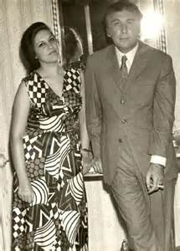 Qabbani and second wife Balqis

<http://muftah.org/feminism-nizar-qabbani/#.VW0kBuuQzdk> (accessed 07/15/15)

**On Poetry and Poetic Form**

Qabbani discussed poetry and poetic form in detail. He continually urged innovation in poetry. He rejects the idea of limiting poetry to traditional ‘metered, rhymed discourse’ in *Tufulat Nahd*, (*The Childhood of a Breast* طفولة نهد 1947). He did not criticize the sixteen traditional meters but wanted to free poetry from any limits or mechanical definitions. He views the poet as an engineer who should have unlimited freedom to engineer poetry from letters and sounds.

Qabbani developed his concept of poetic rhythm after writing his collection *Mi'at Risalat Hubb*

(مئة رسالة حب 1970), in which he used prose for his poems. Qabbani was accused of bringing alien influences into Arabic literature, but he insisted on adopting the prose poem because he considered it uniquely capable of allowing him to express his creativity.

**Language and the Poet's Role**

Qabbani highlighted that Arabic was split between classical standard Arabic and the vernaculars. He saw Arabs linguistically divided between the formal and the common, using one language at home and another in formal or literary circumstances. He believed in the need for a third language that took the best from the classical and the vernacular, in order to connect spoken speech with written discourse or a simplified poetic language that can be understood by all audiences.

**Political Activism**

Following the Arab-Israeli war of 1967, his themes shifted almost completely to politics. His

*Hawamish 'ala daftar al-naksa* **(**هوامش على دفتر النكسة *Marginal Notes on the Notebook of the Setback* 1967) was an attack on Arab leadership during the 1967 Arab -Israeli War.

Qabbani's poetry reflects the frustrated aspirations of Arab intellectuals who are alienated and who feel deceived by their political regimes. He laments Arab nations plagued by tyrants who are constantly defeated. He calls Arab dictators, the enemy, vampires, hypocrites, corrupt, opportunists and profiteers.

He sees intellectuals brutalized by tyranny and censorship. His allusions to Sharm el-Sheikh, Haifa, Ramallah and Golan Heights are reminders of Arab failures. In his poetry, he introduces Palestine as an Arab woman ravaged by invaders.

* *Childhood of a Breast* (1948) طفولة نهد
* *Samba* (1949) سامبا
* *You Are Mine* (1950) أنت لي
* *Poems* (1956) قصائد
* *My Beloved* (1961) حبيبتي
* *Drawing with Words* (1966) الرسم بالكلمات
* *Diary of an Indifferent Woman* (1968) يوميات امرأة لا مبالية
* *Savage Poems* (1970) قصائد متوحشة
* *Book of Love* (1970) كتاب الحب
* *100 Love Letters* (1970) مئة رسالة حب
* *Poems Against The Law* (1972) أشعار خارجة على القانون
* *I Love You, and the Rest is to Come* (1978) أحبك أحبك و البقية تأتي
* *To Beirut the Feminine, With My Love* (1978) إلى بيروت الأنثى مع حبي
* *May You Be My Love For Another Year* (1978) كل عام وأنت حبيبتي
* *I Testify That There Is No Woman But you* (1979) أشهد أن لا امرأة إلا أنت
* *Secret Diaries of Baheyya the Egyptian* (1979) اليوميات السرية لبهية المصرية
* *I Write the History of Woman Like So* (1981) هكذا أكتب تاريخ النساء
* *The Lover's Dictionary* (1981) قاموس العاشقين
* *A Poem For Balqis* (1982) قصيدة بلقيس
* *Love Does Not Stop at Red Lights* (1985) الحب لا يقف على الضوء الأحمر
* *Insane Poems* (1985)أشعار مجنونة
* *Poems Inciting Anger* (1986) قصائد مغضوب عليها
* *Love Shall Remain My Lord* (1987) سيبقى الحب سيدي
* *The Trilogy of the Children of the Stones* (1988) ثلاثية أطفال الحجارة
* *Secret Papers of a Karmathian Lover* (1988) الأوراق السرية لعاشق قرمطي
* *Biography of an Arab Executioner* (1988) السيرة الذاتية لسياف عربي
* *I Married You, Liberty!* (1988) تزوجتك أيتها الحرية
* *A Match in My Hand , And Your Petty Paper Nations* (1989) الكبريت في يدي ودويلاتكم من ورق
* *No Victor Other Than Love* (1989) لا غالب إلا الحب
* *Do You Hear the Cry of My Sadness?* (1991) هل تسمعين صهيل أحزاني ؟
* *Marginal Notes on the Book of Defeat* (1991) هوامش على دفتر النكسة
* *I'm One Man and You are a Tribe of Women* (1992) أنا رجل واحد وأنت قبيلة من النساء
* *Fifty Years of Praising Women* (1994) خمسون عاما في مديح النساء
* *Nizarian Variations of Arabic Maqam of Love* (1995) تنويعات نزارية على مقام العشق
* *Alphabet of Jasmine* (1998) أبجدية الياسمين

Websites of Interest

<http://nizarq.com> his poems may be downloaded from this site

<http://www.poemhunter.com/nizar-qabbani/>

<http://muftah.org/feminism-nizar-qabbani/#.VW0kBuuQzdk>

<http://www.skase.sk/Volumes/JLS03/pdf_doc/06.pdf>

<https://alhayatwadounia.wordpress.com/2011/05/01/nizar-qabbani-more-powerful-than-all-the-arab-regimes-put-together/>

<http://www.jadaliyya.com/pages/index/1754/nizar-qabbanis-poetry-buses>

Recitations of his poetry

Aynak

<https://www.youtube.com/watch?v=lEkOvwkPNPY>

Ma bayna hub wa hub

<https://www.youtube.com/watch?v=jbVHash0_bU>

al-hubb al-mustahil

<https://www.youtube.com/watch?v=k8VtWOYktbQ>